**ICT LAB 07 “HTML AND JAVASCRIPT”**

**NAME:- YASH RAJ**

**ROLL NUMBER:- 24K-0737**

**Index.html:**

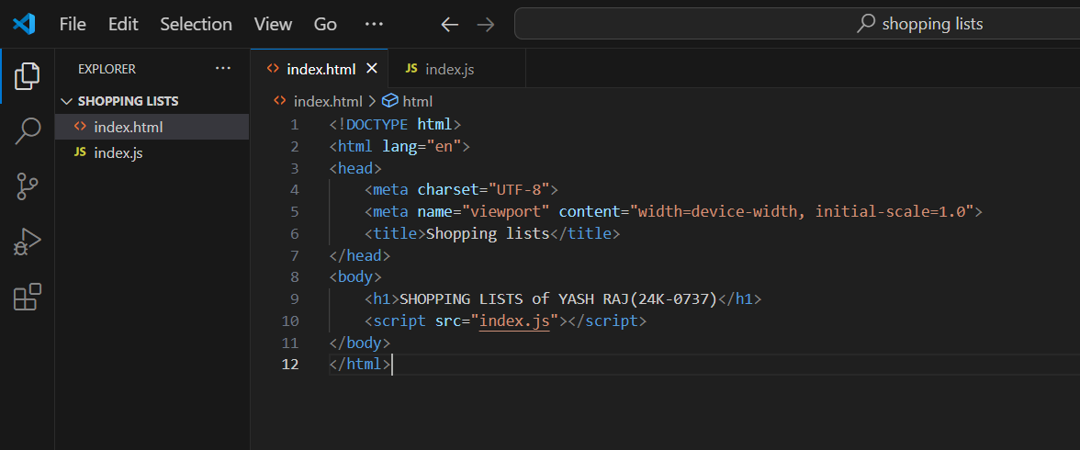

**Index.html output:**

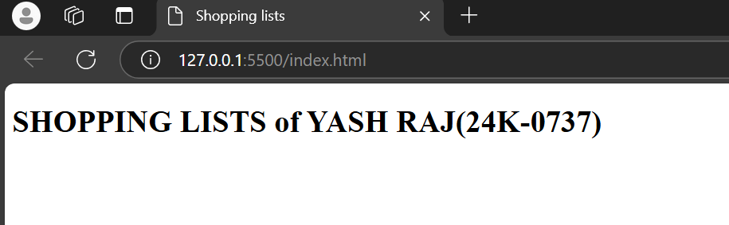

**Index.js:**

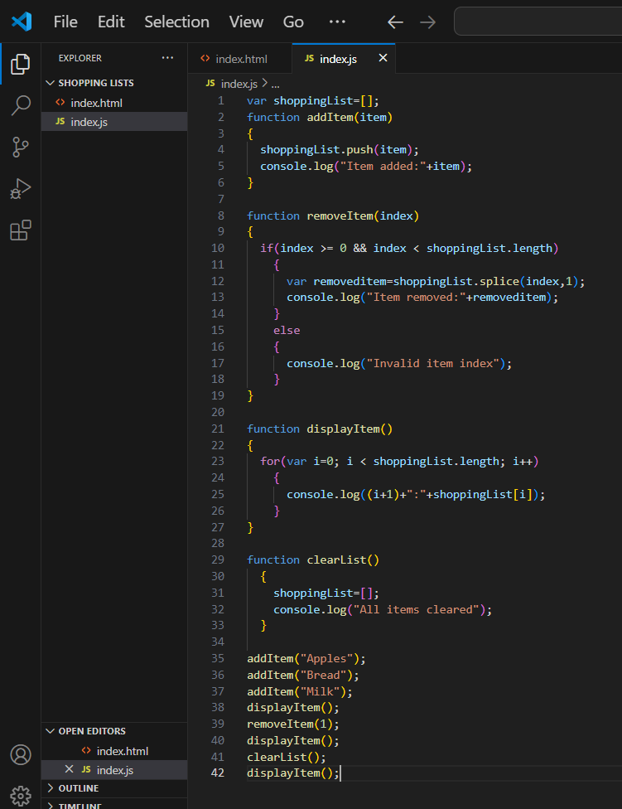

**Index.js output:**

